LoadRunner Case Study

Frist we have to go to create the script then parameterize the test then we have to replay the test

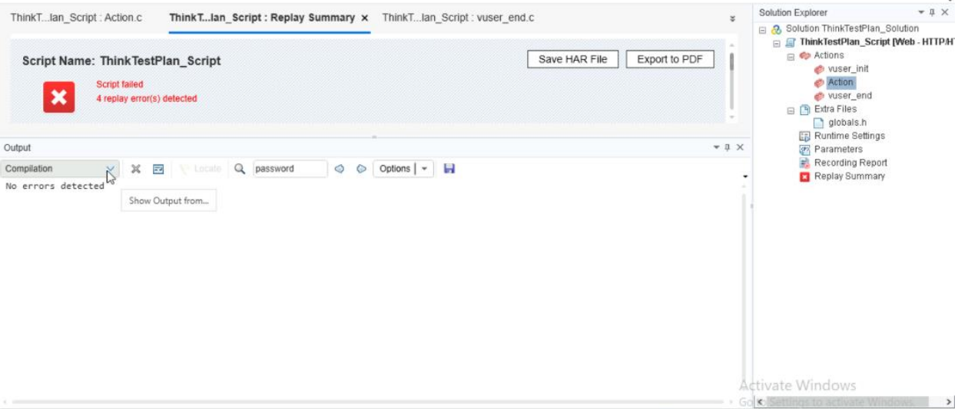

Then we have to open up the controller and add virtual users as well as

Insert different graphs which we require



